**Target Business Case Study**

**🛒 Target Brazil E-Commerce Case Study**

**📌 Project Overview**

Analyzed 100,000+ e-commerce orders from Target Brazil (2016–2018) to uncover operational insights across order processing, pricing, payments, freight, customer behavior, and delivery performance.

**🎯 Objectivess**

As a data analyst at Target, the goal was to extract actionable insights from a multi-table dataset and recommend improvements in logistics, pricing, and customer experience.

**📂 Dataset Summary**

* Source: [Google Drive Folder](https://drive.google.com/drive/folders/1TGEc66YKbD443nslRi1bWgVd238gJCnb)
* Format: 8 CSV files
* Tables: orders, order_items, customers, sellers, payments, reviews, products, geolocation

**🔍 Key Explorations & Insights**

**🧭 Exploratory Analysis**

* Identified data types and structure across all tables
* Mapped customer distribution by city and state
* Extracted order time range and seasonal patterns

**📈 Order Trends**

* Analyzed yearly and monthly growth in order volume
* Segmented order times into Dawn, Morning, Afternoon, Night
* Tracked monthly order counts per state

**💰 Economic Impact**

* Calculated % increase in payment value from Jan–Aug (2017 vs 2018)
* Aggregated total & average order price and freight by state

**🚚 Delivery Performance**

* Computed delivery time and deviation from estimated delivery
* Ranked states by:
* Highest/lowest average freight cost
* Fastest/slowest delivery time
* Most efficient delivery vs estimated date

**💳 Payment Analysis**

* Monthly breakdown of payment types used
* Distribution of orders by installment count

**🛠️ Tools & Skills Used**

* SQL and BigQuery
* Data cleaning & transformation
* Time-series analysis
* Geo-mapping & state-level aggregation
* Business storytelling with data

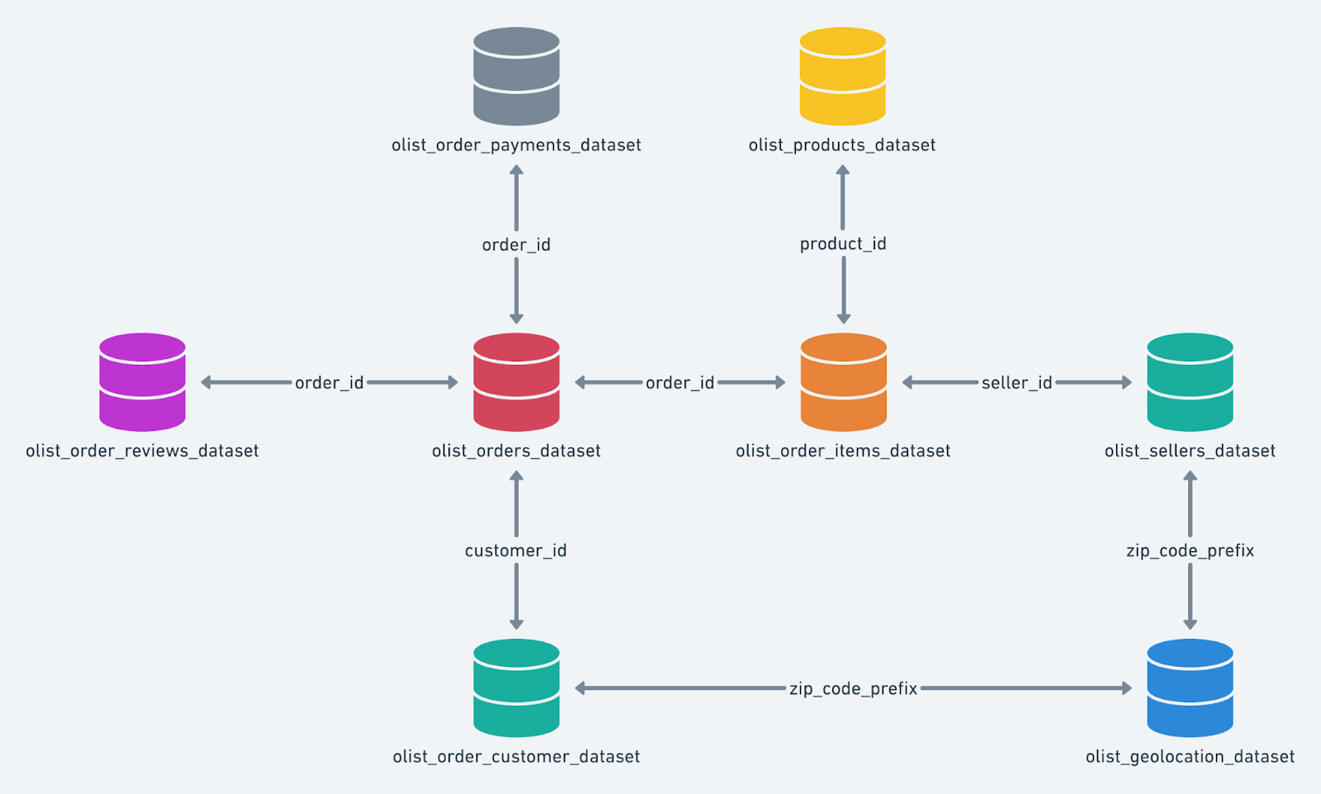

**Details:**

Name: Nishanth Gowda

Email ID: nishanthgowdahsn27@gmail.com

---------------------------------------------------------

**1. Import the dataset and do the usual exploratory analysis steps like checking the structure & characteristics of the dataset:**

**1.1 Data type of all columns in all the table.**

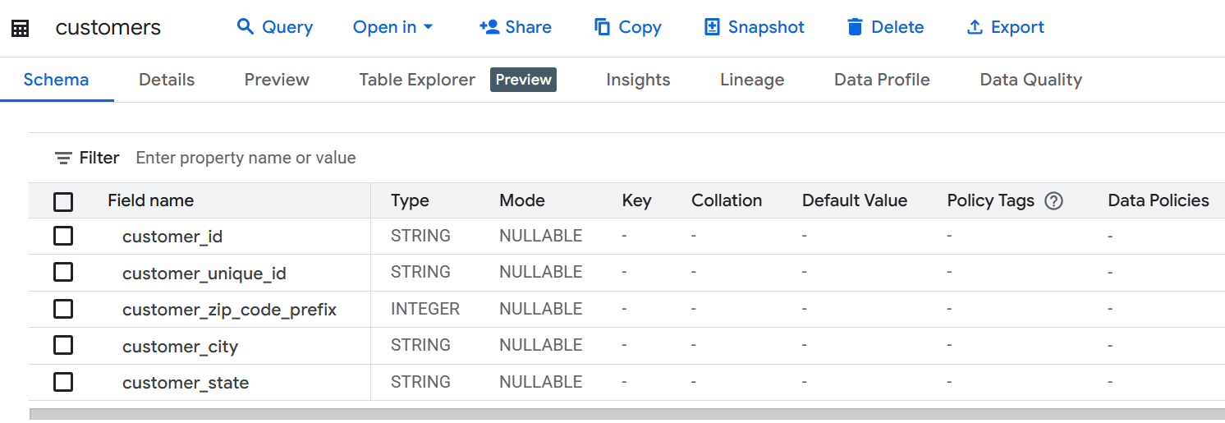

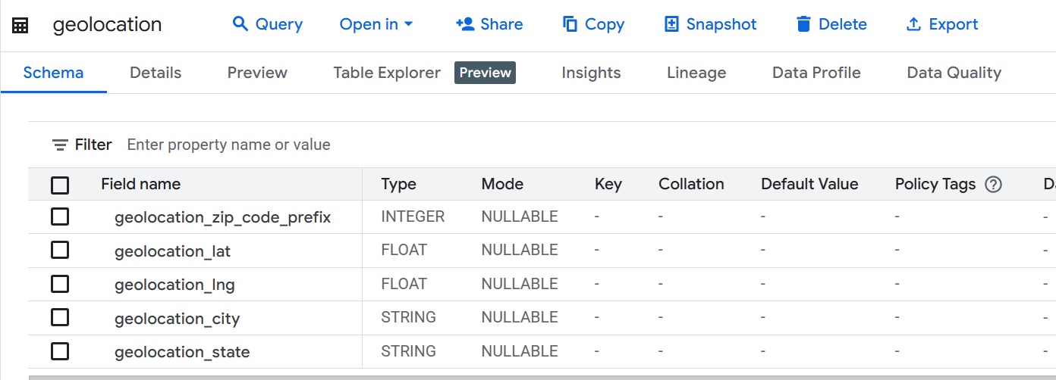

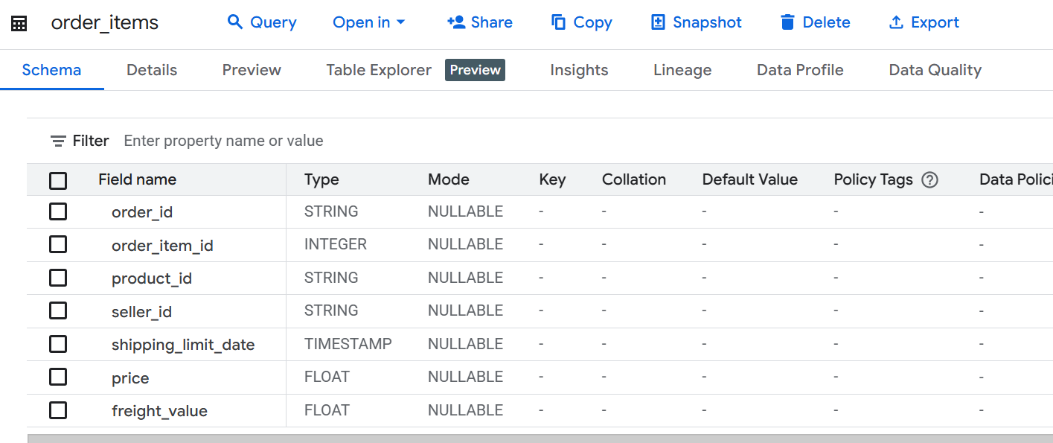

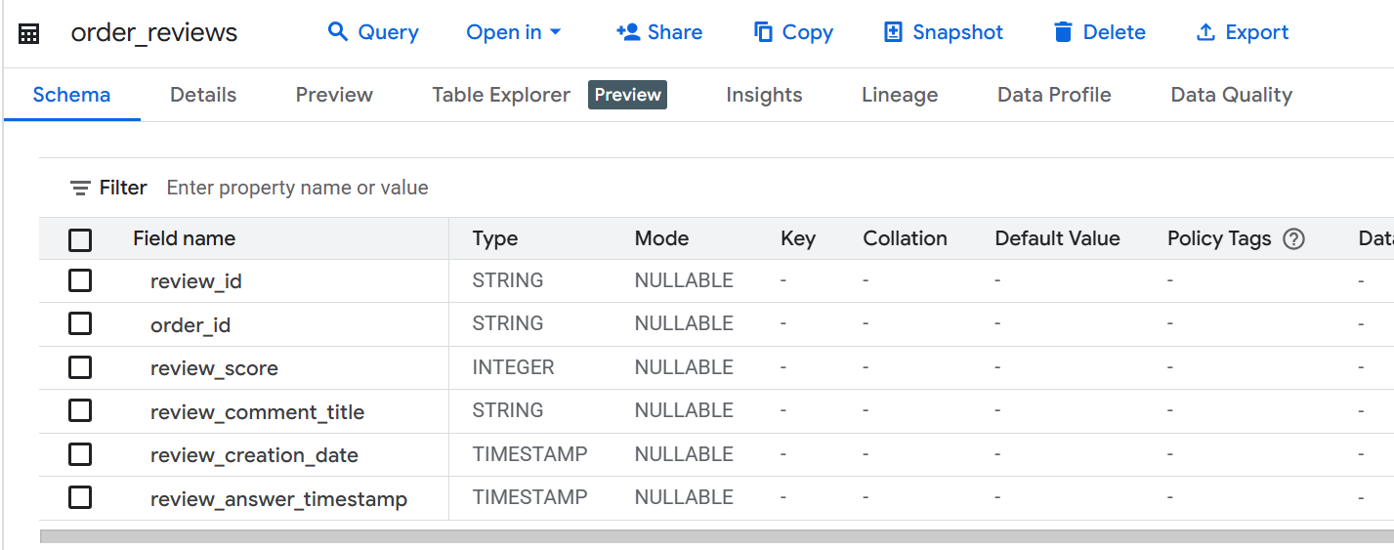

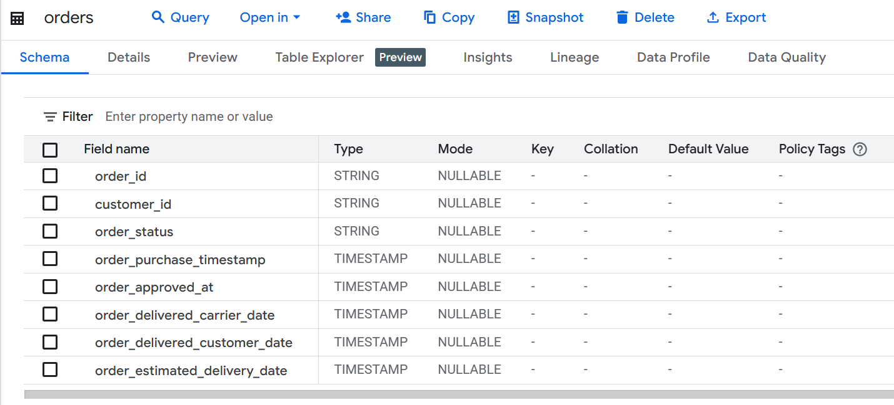

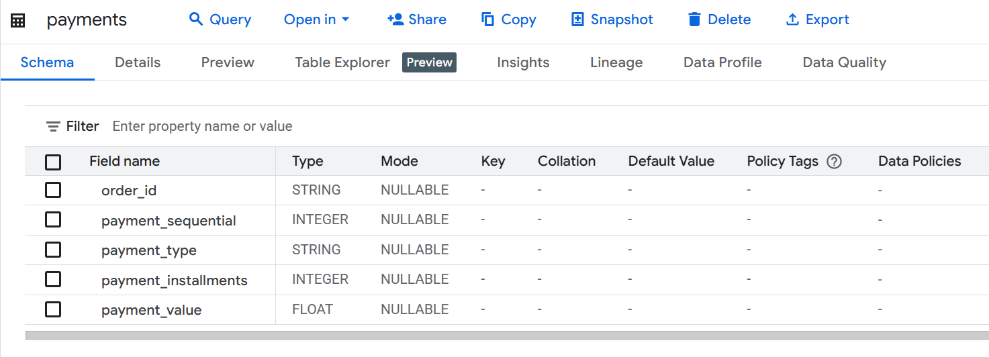

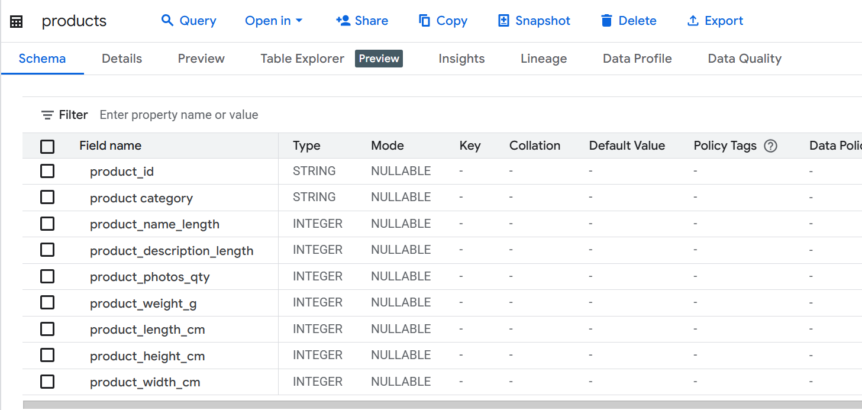

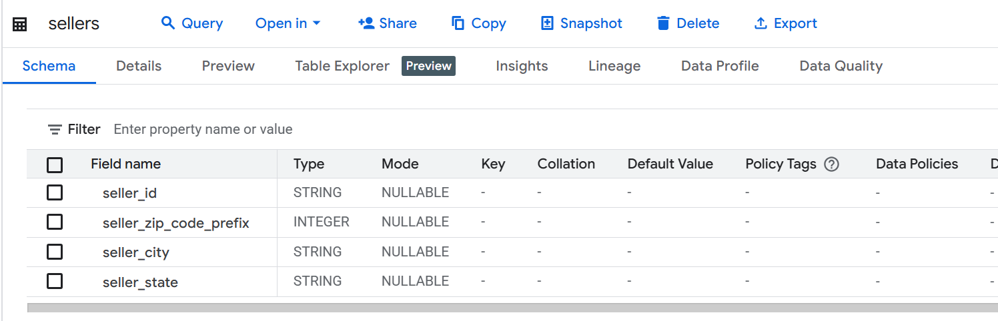

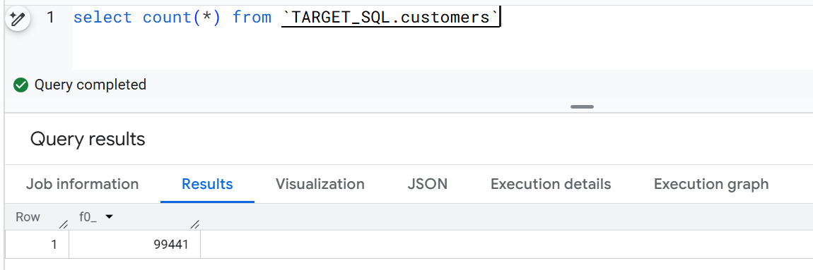

Insights:

Here 1Lakh customer records used for analysis

**1.2. Time range between which the orders were placed.**

SELECT MIN(order_purchase_timestamp) AS order_start_date,

MAX(order_purchase_timestamp) AS order_end_date,

FROM `TARGET_SQL.orders`

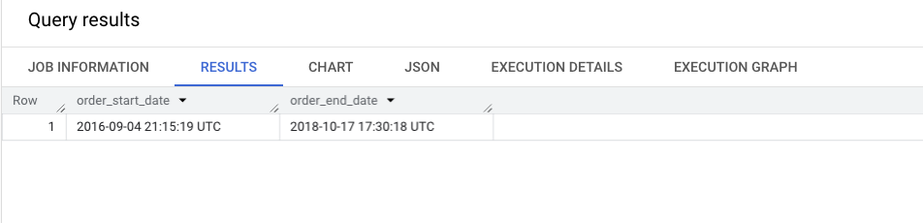

Insights:

Start date = 04-09-2016

End date = 17-10-2018

Time Period = 2 years, 7months, 14days

**1.3. Count the number of Cities & States of customers who ordered during the given period.**

WITH min_max_dates AS (

SELECT

MIN(order_purchase_timestamp) AS min_date,

MAX(order_purchase_timestamp) AS max_date

FROM `TARGET_SQL.orders`

)

SELECT COUNT(DISTINCT cust.customer_id) AS cities_state_count

FROM `TARGET_SQL.customers` AS cust

JOIN `TARGET_SQL.orders` AS ord

ON cust.customer_id = ord.customer_id

JOIN min_max_dates AS dates

ON ord.order_purchase_timestamp BETWEEN dates.min_date AND dates.max_date;

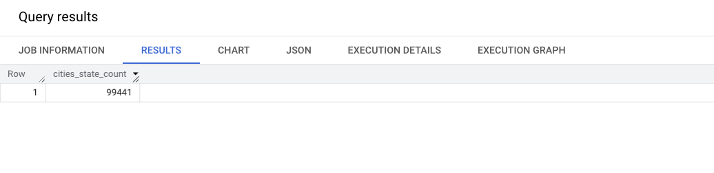

select count(*) as State

from (select distinct customer_state, count(customer_state)  from `TARGET_SQL.customers`

group by customer_state)

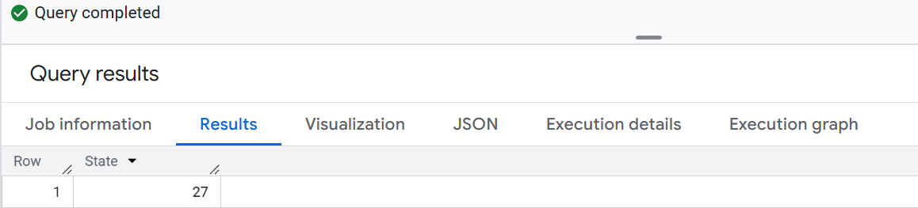

select count(*) as City

from (select distinct customer_city, count(customer_city)  from `TARGET_SQL.customers`

group by customer_city)

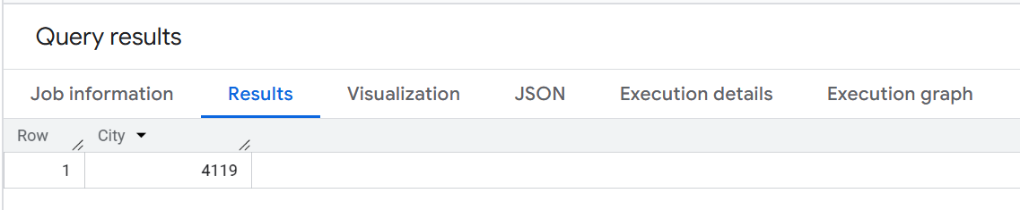

Insights:

There were total 99441 customers from which order is placed

Total unique state: 27

Total unique city: 4119

**------------------------------------------------------------------------------------------------------------------------------------------**

**2. In-depth Exploration:**

**2.1. Is there a growing trend in the no. of orders placed over the past years?**

WITH order_data AS (

SELECT

order_id,

order_purchase_timestamp,

FORMAT_DATETIME('%Y-%m', order_purchase_timestamp) AS past_years

FROM `TARGET_SQL.orders`

)

SELECT

past_years,

COUNT(*) AS order_month_count,

COUNT(*)-LAG(COUNT(*)) OVER(ORDER BY past_years) AS growth_trend

FROM order_data

GROUP BY past_years

ORDER BY past_years

LIMIT 10

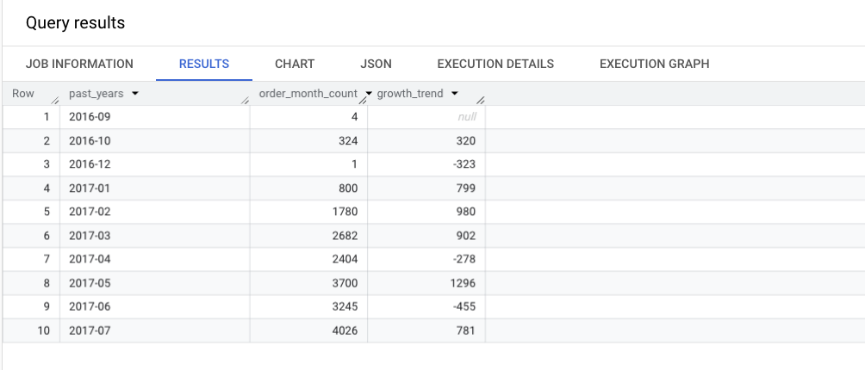

Insights:

We can clearly see that there is a growing trend in the growth_tred column

Highest order month = May-2017

**2.2. Can we see some kind of monthly seasonality in terms of the no. of orders being placed?**

WITH order_data AS (

SELECT

FORMAT_DATETIME('%m', order_purchase_timestamp) AS past_month,

COUNT(order_id) AS order_month_count

FROM `TARGET_SQL.orders`

GROUP BY past_month

)

SELECT

past_month,

AVG(order_month_count) OVER() AS avg_month_count,

order_month_count - ROUND(AVG(order_month_count) OVER(), 2) AS monthly_seasonal

FROM order_data

ORDER BY past_month

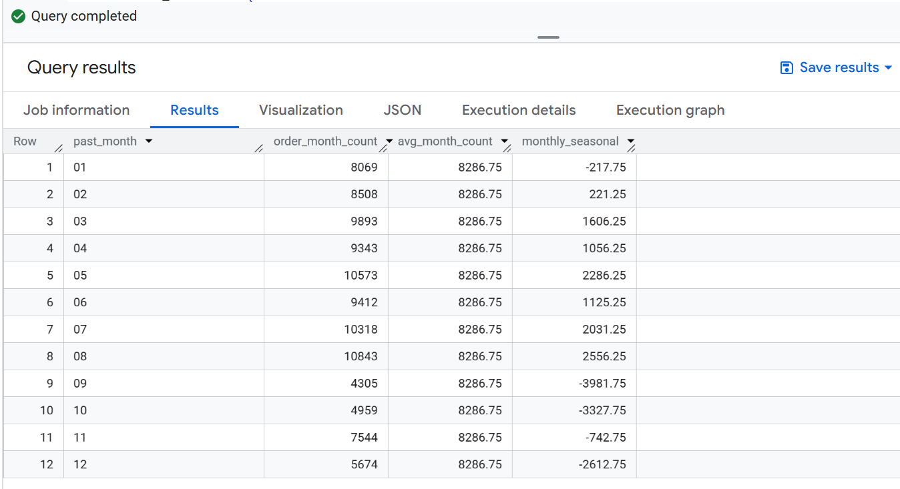

Insights:

Here we can cleary see the number of orders are more in March which is in summer till July. Company needs to enguage customer on other months by providing offers on winter cloths and other products.

**2.3. During what time of the day, do the Brazilian customers mostly place their orders?**

**(Dawn, Morning, Afternoon or Night)**

* + **0-6 hrs : Dawn**
  + **7-12 hrs : Mornings**
  + **13-18 hrs : Afternoon**
  + **19-23 hrs : Night**

SELECT order_purchase_timezone, count(order_purchase_timezone) FROM (

SELECT order_purchase_timestamp,

CASE

WHEN extract(hour FROM order_purchase_timestamp) between 0 and 6 THEN 'Dawan'

WHEN extract(hour FROM order_purchase_timestamp) between 7 and 12 THEN 'Mornings'

WHEN extract(hour FROM order_purchase_timestamp) between 13 and 18 THEN 'Afternoon'

ELSE 'Night'

END AS order_purchase_timezone

FROM `TARGET_SQL.orders`)

GROUP BY order_purchase_timezone

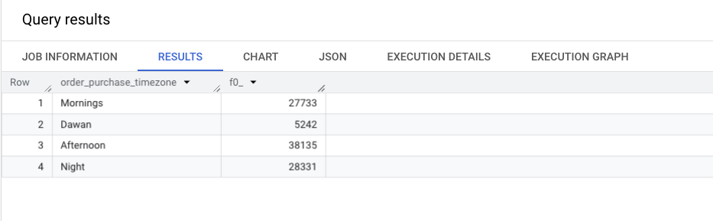

Insights:

Here the time slots are:

Dawan: 12am-6am, Morning: 7am-12pm, Afternoon: 1pm-6pm, Night:7pm-11pm

During afternoon most people are awake and we can recommend more advertisements during this period to enguage the customers.

----------------------------------------------------------------------------------------------------------------------------------------------

**3. Evolution of E-commerce orders in the Brazil region:**

**3.1. Get the month on month no. of orders placed in each state.**

SELECT geo.geolocation_state,

extract(month FROM ord.order_purchase_timestamp) AS order_month,

count(ord.order_id) AS month_on_month

FROM `TARGET_SQL.geolocation` AS geo

JOIN `TARGET_SQL.customers` AS cust

ON geo.geolocation_zip_code_prefix = cust.customer_zip_code_prefix

JOIN `TARGET_SQL.orders` AS ord

ON cust.customer_id = ord.customer_id

GROUP BY geo.geolocation_state, order_month

order by geo.geolocation_state, order_month

limit 15

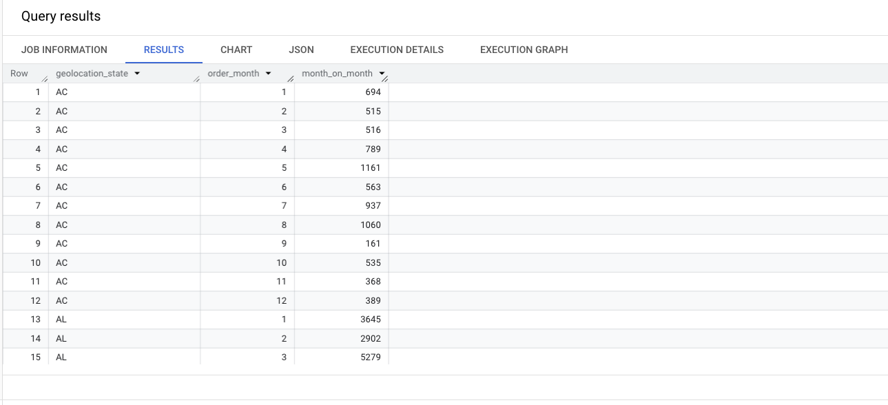

Insights:

Most of the orders are from AL state, company needs to find the reasons for why number of orders more in AL state and implement same stratagy on other state.

**3.2. How are the customers distributed across all the states?**

SELECT geo.geolocation_state,count(distinct cust.customer_id) AS no_customers

FROM `TARGET_SQL.geolocation` AS geo

JOIN `TARGET_SQL.customers` AS cust

ON geo.geolocation_zip_code_prefix = cust.customer_zip_code_prefix

GROUP BY geo.geolocation_state

limit 10

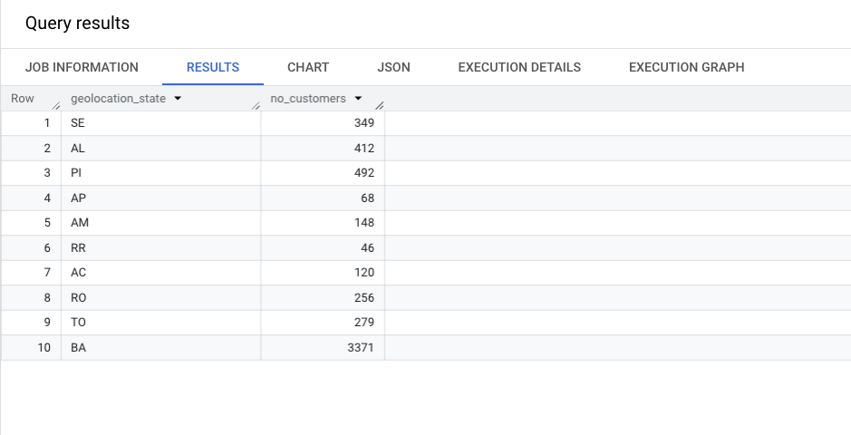

Insights:

Maximum customer count: BA(~3371), AL(~412)

Company need to concentrate more on other state customer logins

----------------------------------------------------------------------------------------------------------------------------------------------

**4. Impact on Economy: Analyze the money movement by e-commerce by looking at order prices, freight and others.**

**4.1.Get the % increase in the cost of orders from year 2017 to 2018 (include months between Jan to Aug only).**

WITH monthly_avg_payment AS (

SELECT

EXTRACT(YEAR FROM ord.order_purchase_timestamp) AS year_x,

EXTRACT(MONTH FROM ord.order_purchase_timestamp) AS month_x,

AVG(pmt.payment_value) AS avg_payment

FROM `TARGET_SQL.orders` AS ord

JOIN `TARGET_SQL.payments` AS pmt

ON ord.order_id = pmt.order_id

WHERE EXTRACT(YEAR FROM ord.order_purchase_timestamp) IN (2017, 2018)

AND EXTRACT(MONTH FROM ord.order_purchase_timestamp) BETWEEN 1 AND 8

GROUP BY year_x, month_x

)

SELECT

year_x,

month_x,

avg_payment,

ROUND(

(avg_payment - LAG(avg_payment) OVER (ORDER BY year_x, month_x)) * 100

/ LAG(avg_payment) OVER (ORDER BY year_x, month_x), 2) AS percentage_increase

FROM monthly_avg_payment

ORDER BY year_x, month_x;

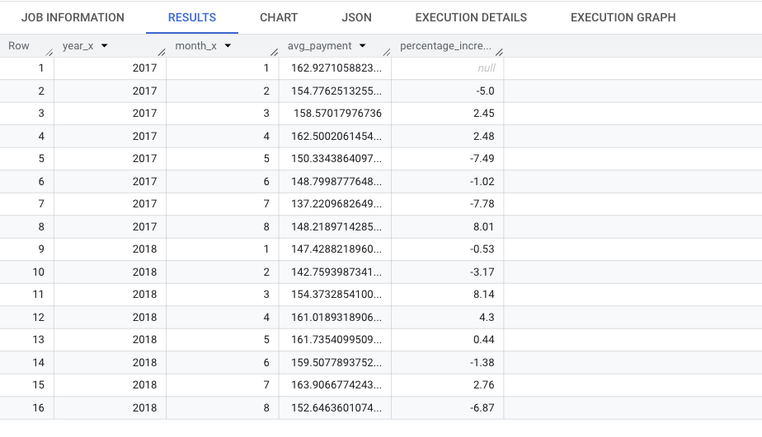

Insights:

We can see that % increase in the cost of orders increased from 2017 to 2018

**4.2. Calculate the Total & Average value of order price for each state.**

SELECT

geo.geolocation_state,

SUM(pmt.payment_value) AS total_price,

AVG(pmt.payment_value) AS avg_price

FROM `TARGET_SQL.geolocation` AS geo

JOIN `TARGET_SQL.customers` AS cust

ON geo.geolocation_zip_code_prefix = cust.customer_zip_code_prefix

JOIN `TARGET_SQL.orders` AS ord

ON ord.customer_id = cust.customer_id

JOIN `TARGET_SQL.payments` AS pmt

ON ord.order_id = pmt.order_id

GROUP BY geo.geolocation_state

ORDER BY total_price DESC

LIMIT 10;

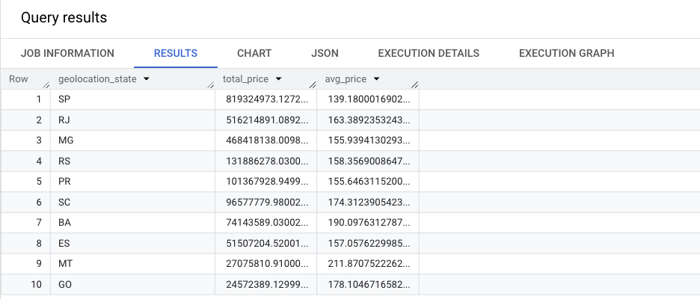

Insights:

We observe the total price and average order price for each state

**4.3. Calculate the Total & Average value of order freight for each state.**

SELECT

geo.geolocation_state,

SUM(orditm.freight_value) as total_freight_value,

AVG(orditm.freight_value) as avg_freight_value

FROM `TARGET_SQL.order_items` AS orditm

JOIN `TARGET_SQL.orders` AS ord

ON orditm.order_id = ord.order_id

JOIN `TARGET_SQL.customers` AS cust

ON ord.customer_id = cust.customer_id

JOIN `TARGET_SQL.geolocation` AS geo

ON cust.customer_zip_code_prefix = geo.geolocation_zip_code_prefix

GROUP BY geo.geolocation_state

LIMIT 10

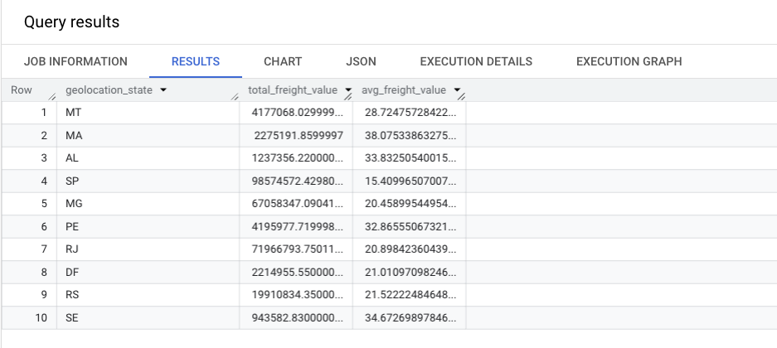

Insights:

We observe the total value and average value of order freight for each state

**Note:**

**Freight: goods**[**transported**](https://www.google.com/search?sca_esv=a635e86d0750cab2&sxsrf=AE3TifN10h5NIfR3NRfnPAMXojvk9t32PA:1755565967396&q=transported&si=AMgyJEu2dDdE8z0NZJJsg3Fd0ziY_-EVTWtAb1WL-EKk4gSrcyS0eDg6PD89M-7VZyt9bFoci94LLZ58RTLawIl1uza2bPb5Zm264XOEp1Folmm4i_YRAwQ%3D&expnd=1&sa=X&sqi=2&ved=2ahUKEwi0_vbu2JWPAxWwSmwGHd1NN8IQyecJegQIORAd)**in bulk by truck, train, ship, or aircraft.**

**---------------------------------------------------------------------------------------------------------------------------------------------**

**5.Analysis based on sales, freight and delivery time.**

**5.1. Find the no. of days taken to deliver each order from the order’s purchase date as delivery time.  
Also, calculate the difference (in days) between the estimated & actual delivery date of an order.  
Do this in a single query.(Delivery time)  
  
You can calculate the delivery time and the difference between the estimated & actual delivery date using the given formula:**

* + **time_to_deliver = order_delivered_customer_date - order_purchase_timestamp**
  + **diff_estimated_delivery = order_delivered_customer_date - order_estimated_delivery_date**

SELECT

order_id,

customer_id,

date_diff(order_delivered_customer_date, order_purchase_timestamp, day) as time_to_deliver,

date_diff(order_delivered_customer_date, order_estimated_delivery_date, day) as diff_estimated_delivery

FROM `TARGET_SQL.orders`

WHERE order_delivered_customer_date IS NOT NULL

LIMIT 10;

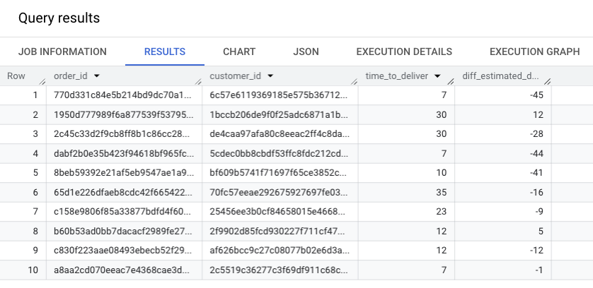

Insights:

We can see the difference between orderd estimated date and delivered date

Company need to concentrate to decrease this difference.

**5.2. Find out the top 5 states with the highest & lowest average freight value.( Freight value)**

WITH freight_value AS(

SELECT

geo.geolocation_state as state,

AVG(orditm.freight_value) as avg_freight_value

FROM `TARGET_SQL.order_items` AS orditm

JOIN `TARGET_SQL.orders` AS ord

ON orditm.order_id = ord.order_id

JOIN `TARGET_SQL.customers` AS cust

ON ord.customer_id = cust.customer_id

JOIN `TARGET_SQL.geolocation` AS geo

ON cust.customer_zip_code_prefix = geo.geolocation_zip_code_prefix

GROUP BY geo.geolocation_state

)

-- HIGHEST

(SELECT *

FROM freight_value

ORDER BY avg_freight_value

LIMIT 5)

UNION ALL

-- Lowest

(SELECT *

FROM freight_value

ORDER BY avg_freight_value DESC

LIMIT 5)

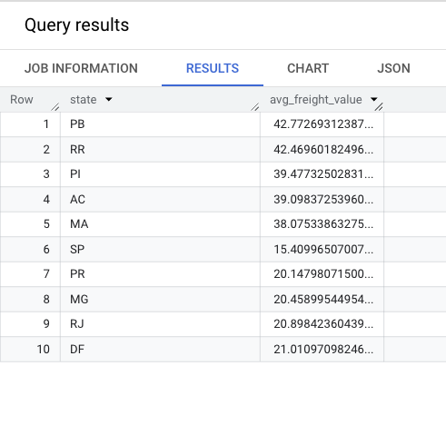

Insights:

We observe that:

Maximum avg freight value = PB and RR (~42 units)

Minimum avg freight value = RJ and DF (~21 units)

**5.3.Find out the top 5 states with the highest & lowest average delivery time.(Delivery time)**

WITH high_low as (

SELECT

geo.geolocation_state as state,

AVG(DATE_DIFF(ord.order_estimated_delivery_date, ord.order_delivered_customer_date, day)) as diff_estimated_delivery

FROM `TARGET_SQL.orders` AS ord

JOIN `TARGET_SQL.customers` AS cust

ON ord.customer_id = cust.customer_id

JOIN `TARGET_SQL.geolocation` AS geo

ON cust.customer_zip_code_prefix = geo.geolocation_zip_code_prefix

GROUP BY geo.geolocation_state

)

(SELECT state, diff_estimated_delivery

FROM high_low

ORDER BY diff_estimated_delivery DESC

LIMIT 5)

UNION ALL

(SELECT state, diff_estimated_delivery

FROM high_low

ORDER BY diff_estimated_delivery ASC

LIMIT 5)

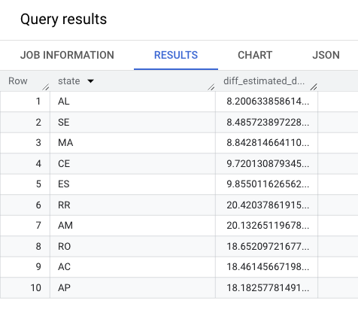

Insights:

We observed that:

Minimum delivery time = AL and SQ(~8.2days)

Maximum delivery time = AC and AP(~20.4)

**5.4. Find out the top 5 states where the order delivery is really fast as compared to the estimated date of delivery.  
You can use the difference between the averages of actual & estimated delivery date to figure out how fast the delivery was for each state.**

with top_five as (

SELECT

geo.geolocation_state as state,

AVG(DATE_DIFF(ord.order_estimated_delivery_date, ord.order_purchase_timestamp, day)) as est_date,

AVG(DATE_DIFF(ord.order_delivered_customer_date, ord.order_purchase_timestamp, day)) as delivered_date

FROM `TARGET_SQL.orders` AS ord

JOIN `TARGET_SQL.customers` AS cust

ON ord.customer_id = cust.customer_id

JOIN `TARGET_SQL.geolocation` AS geo

ON cust.customer_zip_code_prefix = geo.geolocation_zip_code_prefix

GROUP BY geo.geolocation_state

)

select top_five.state, top_five.delivered_date

from top_five

where top_five.delivered_date < top_five.est_date

ORDER BY top_five.delivered_date DESC

limit 5

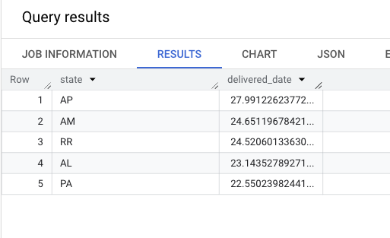

Insights:

Top 5 States(AP, AM, RR, AL, PA)

where order delivery time is faster than the estimated delivery time(~24 days)

----------------------------------------------------------------------------------------------------------------------------------------------

**6. Analysis based on the payments**

**6.1. Find the month on month no. of orders placed using different payment types.**

SELECT pmt.payment_type,

EXTRACT(YEAR FROM ord.order_purchase_timestamp) AS year_x,

EXTRACT(MONTH FROM ord.order_purchase_timestamp) AS month_x,

COUNT(pmt.order_id) AS order_count

FROM `TARGET_SQL.payments` AS pmt

JOIN `TARGET_SQL.orders` AS ord

ON pmt.order_id = ord.order_id

GROUP BY pmt.payment_type ,EXTRACT(YEAR FROM ord.order_purchase_timestamp), EXTRACT(MONTH FROM ord.order_purchase_timestamp)

ORDER BY pmt.payment_type, year_x, month_x

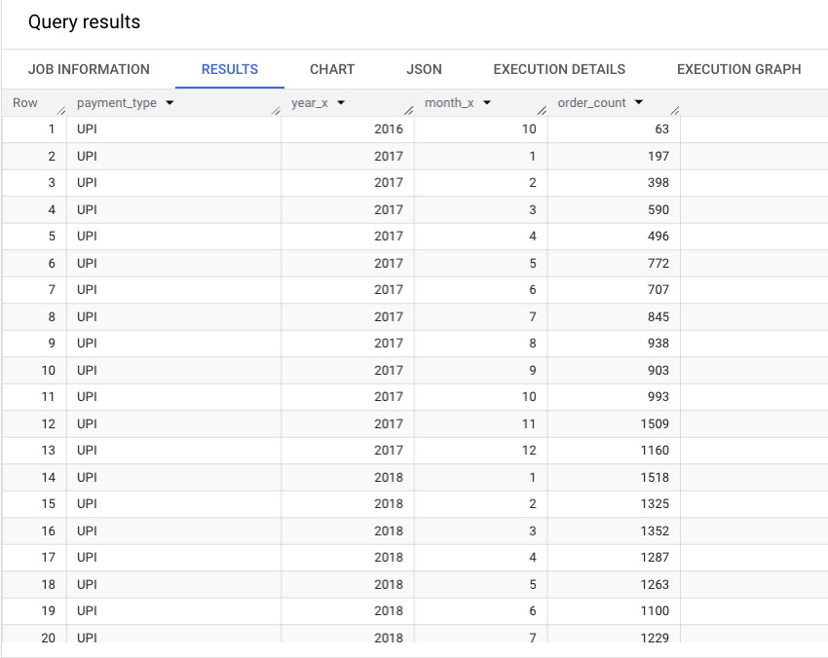

Insights:

We observed that:

Order count has been increased on 2018 and most of the orders are of UPI type

**6.2. Find the no. of orders placed on the basis of the payment installments that have been paid.**

SELECT payment_type, COUNT(DISTINCT order_id) AS order_count

FROM `TARGET_SQL.payments`

WHERE payment_installments > 0

GROUP BY payment_type

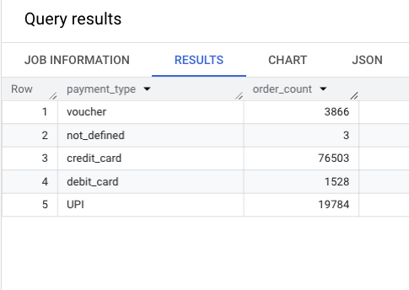

Insights:

We observed that:

Maximum orders are from UPI payment.

Minimum order are from debit card type of payment